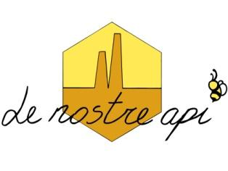
LE NOSTRE API
ASSOCIAZIONE APICOLTORI EMILIA-ROMAGNA
Via San Carlo 526/a 40042 Castel San Pietro T. (Bo)
www.apicoltoribologna.it - info@lenostreapi.it
P.IVA 02727291201 – C.F. 91278010375

CONVENZIONI 2026

CONVENZIONE LE APINE
https://drive.google.com/file/d/1vNuflI_cFmhQV9rutxEpZuO8JgSntDZu/view?usp=sharing

CONVENZIONE MONDO APE
https://drive.google.com/file/d/1T-lCjw-5io7NVu6yd18__6-0ZrQbVqlK/view?usp=drive_link

CONVENZIONE EDILCOLOR
https://drive.google.com/file/d/1bEm7Nh96fSDLXQZj5z2z7IMc2HccfvN-/view?usp=sharing

CONVENZIONE BORGHI PROGETTO ENOLOGIA
https://drive.google.com/file/d/1VpH2_6ERBcKblmp6YLPVNuOoPYVziEkH/view?usp=drive_link

CONVENZIONE PITARRESI
https://drive.google.com/file/d/1AJ5kOh6gutV8mqQLAvD2k1WsF3q5J5XH/view?usp=drive_link

CONVENZIONE TORRICELLI BOTTI
https://drive.google.com/drive/folders/1cdiv8UyzwuY6mIp-8yS5lk0hypH_S8I3?usp=drive_link

CONVENZIONE RIVISTA LAPIS
https://docs.google.com/document/d/1Oo76nG6EjKQ4mdgd4LwuQAKQYS3uCGrD/edit?usp=drive_link&ouid=107258399082895892632&rtpof=true&sd=true

